**Tugas 7 – Membuat Frame**

Code :

frame.html

<frameset rows="15%,*,10%">

<frame src="atas.html">

<frameset cols="18%,*,18%">

<frame src="kiri.html">

<frame src="home.html" name="home">

<frame src="kanan.html">

</frameset>

<frame src="bawah.html">

</frameset>

home.html  
  
<style>

body {

background: black;

}

.star {

position: absolute;

width: 2px;

height: 2px;

background: rgba(255, 255, 255, 0.0);

border-radius: 5px;

}

@keyframes twinkle {

0% {

transform: scale(1, 1);

background: rgba(255, 255, 255, 0.0);

animation-timing-function: ease-in;

}

60% {

transform: scale(0.8, 0.8);

background: rgba(255, 255, 255, 1);

animation-timing-function: ease-out;

}

80% {

background: rgba(255, 255, 255, 0.00);

transform: scale(1, 1);

}

100% {

background: rgba(255, 255, 255, 0.0);

transform: scale(1, 1);

}

}

.container {

margin: 80px 30px 0 30px;

text-align: center;

}

</style>

<body>

<div class="container">

<img src="https://media.giphy.com/media/26xBEamXwaMSUbV72/giphy.gif" alt="">

</div>

</body>

<script

src="https://code.jquery.com/jquery-3.6.0.min.js"

integrity="sha256-/xUj+3OJU5yExlq6GSYGSHk7tPXikynS7ogEvDej/m4="

crossorigin="anonymous"></script>

<script>

for (var i = 0; i < 100; i++) {

var star = '<div class="star" style="animation: twinkle ' + ((Math.random() * 5) + 5) + 's linear ' + ((Math

.random() * 5) + 5) + 's infinite; top: ' + Math.random() * $(window).height() + 'px; left: ' + Math

.random() * $(window).width() + 'px;"></div>';

$('body').append(star);

}

</script>

atas.html

<style>

h1 > a {

text-decoration: none;

color: darkblue;

}

h1 > a:hover {

text-decoration: none;

color: teal;

}

</style>

<body style="background-color: orangered; text-align: center; margin-top: 20px;">

<h1>

<a href="home.html" target="home">

WEB INFORMASI ASTRONOMI

</a>

</h1>

</body>

kanan.html

<style>

ul#top {

margin-top: 40px;

}

ul > li {

margin-bottom: 10px;

}

ul > li > a {

text-decoration: none;

}

ul > li > a:hover {

text-decoration: dashed;

color: white

}

</style>

<body style="background-color: turquoise; margin-top: 20px;">

<!-- <center> -->

<h1 style="text-align: center;">

Bintang

</h1>

<ul id="top" style="list-style-type: none; text-align: right; margin-right: 40px;">

<li><a href="" target="home">Matahari</a></li>

<li><a href="" target="home">Katai</a></li>

<li><a href="" target="home">Neutron</a></li>

<li><a href="" target="home">Pulsar</a></li>

<li><a href="" target="home">Magnetar</a></li>

</ul>

<hr>

<ul style="list-style-type: none; text-align: right; margin-right: 40px;">

<li><a href="" target="home">Black Hole</a></li>

<li><a href="" target="home">Milky Way</a></li>

<li><a href="" target="home">Andromeda</a></li>

<li><a href="" target="home">Ruang lingkup waktu 4 dimensi</a></li>

<li><a href="menu/tachyon.html" target="home">Tachyon</a></li>

</ul>

<!-- </center> -->

</body>

kiri.html

<style>

ul {

margin-top: 40px;

}

ul > li {

margin-bottom: 10px;

}

ul > li > a {

text-decoration: none;

}

ul > li > a:hover {

text-decoration: dashed;

color: white

}

</style>

<body style="background-color: lime; margin-top: 20px;">

<!-- <center> -->

<h1 style="text-align: center;">

PLANET

</h1>

<ul style="list-style-type: none;">

<li><a href="menu/mercury.html" target="home">Merkurius</a></li>

<li><a href="" target="home">Venus</a></li>

<li><a href="menu/earth.html" target="home">Bumi</a></li>

<li><a href="" target="home">Mars</a></li>

<li><a href="" target="home">Jupiter</a></li>

<li><a href="" target="home">Saturnus</a></li>

<li><a href="" target="home">Uranus</a></li>

<li><a href="" target="home">Neptunus</a></li>

</ul>

<!-- </center> -->

</body>

bawah.html

<style>

h1 > a {

text-decoration: none;

color: darkblue;

}

h1 > a:hover {

text-decoration: none;

color: teal;

}

</style>

<body style="background-color: darksalmon; text-align: center; margin-top: 8px;">

<h1>

<a href="home.html" target="home">

Dibuat menggunakan HTML Oleh : Hanif Ahmad Syauqi (10121161)

</a>

</h1>

</body>

menu/earth.html

<style>

.container {

margin: 80px 30px 0 30px;

text-align: center;

}

body {

background-color: #000;

}

</style>

<body>

<div class="container">

<img src="https://media.giphy.com/media/WlBUAWG03Zic8/giphy.gif" alt="">

</div>

</body>

menu/mercury.html

<style>

.container {

margin: 80px 30px 0 30px;

text-align: center;

}

body {

background-color: #000;

}

</style>

<body>

<div class="container">

<img src="https://media.giphy.com/media/l0HlO4V8iCRME3i0g/giphy.gif" alt="">

</div>

</body>

tachyon.html

<style>

body {

background: url(https://media.giphy.com/media/5xtDarHj0ORdxfWtV6g/giphy.gif) no-repeat center center fixed;

-webkit-background-size: cover;

-moz-background-size: cover;

-o-background-size: cover;

background-size: cover;

}

</style>

<body>

</body>

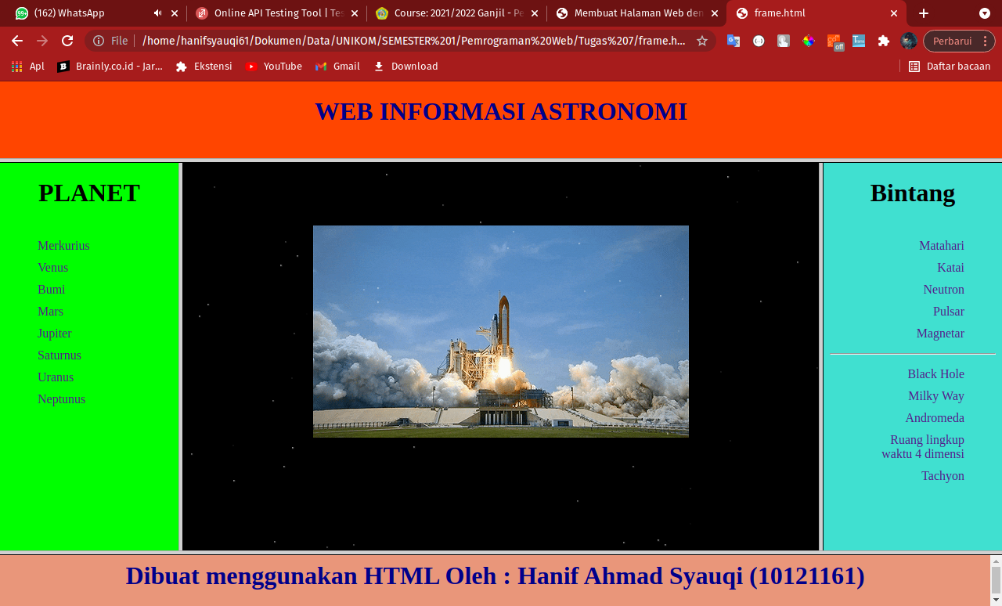Screenshot:

